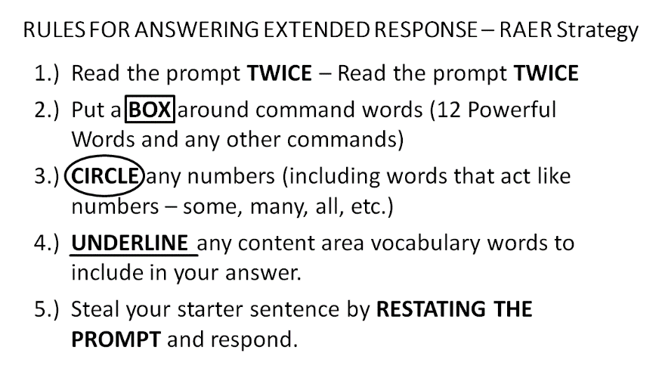
IRACE to Write an Excellent Response!

I – Indent
R– Restate
A– Answer
C– Cite
E– Explain
Other tips:
- Keep your handwriting as neat as possible.
- Use correct spelling and grammar.
- Use your best vocabulary, provide evidence from the text, and do NOT be repetitive!
- When in doubt make sure you explain yourself.
- Re-read your response to check for easy to correct errors.
- BELIEVE IN YOURSELF!!!

